Design and simulation – part 2

Receiver

2022 Semester One

# Introduction

This assignment focuses on the receiver part of Electeng 310 project 1. The due date for the assignment is 7th April 2022. This assignment is worth 10 marks. Only one copy of the document and simulation need to be submitted for each group by the group leader.

# Instructions

Please follow the guidelines outlined here:

• Read the assignment document carefully and complete all of the tasks.

• Tasks are **in bold**.

• Be specific and refer to any images accurately when discussing the work.

• Use the snipping tool available in windows and ensure that all the relevant components are visible, with values clearly shown when copying schematics from LTSpice on to this document.

• Include only one or two periods of any ac waveforms when copying output graphs from LTSpice on to this document.

• Use the closest E12 values for resistors and capacitors to ensure that the circuit is as practical as possible.

# Deliverables

The deliverables of this assignment are:

1. A completed version of this document.

Marks will be given based on:

• Completeness and correctness of the answers in this document.

• Clarity of the screenshots presented.

2. An LTspice simulation file of the entire transmitter and the receiver along with any related libraries required to run it.

Marks will be given based on:

• Clarity, correctness, and tidiness of the simulation.

• Understanding of LTSpice features.

• Ability to simplify the simulation without compromising on the accuracy and practicality of the simulation.

Submit a zipped file with a pdf version of this word document, the .asc file of the simulation, and any libraries of the practical components used. Name the zip file “EE310_GroupXX_Rx_2022.zip”, where XX is your group number.

# 1. Light detector

A light detector circuit is a transimpedance amplifier that converts the photo-current from the photo-diode to an output voltage.

An example light detector circuit with labelled components is shown in Figure 1.



Figure 1: An example of the light detector circuit.

## 1.1 Calculation of theoretical values

Using the theory learned in the design meetings, calculate the values for the light detector circuit in Table 1. Remember to use practical E12 values for all resistors and capacitors.

### 1.1.1 Fill out Table 1 with the expected values, including units.



Table 1: Calculate theoretical values for the light detector

|  |  |
| --- | --- |
|  | 100k |
|  | 7.5pF |
|  | 200khz |

Here, is the cut-off frequency of the light detector circuit.

## 1.2 Design justifications

**Give a brief justification for the value of each parameter chosen in Table 1.**

|  |
| --- |
| : Considering our PWM signal could have noise that we assume to be about 1mV in amplitude, we would want to have a larger gain for our Light detection circuit. We decided on a Vdet peak-to-peak value of 5mV for the worst case Ip of 50nA. This made us decide on a value for R_f of 100k |
| : While we are amplifying the signal, we would want to reduce the amount of noise that gets amplified. This could be done if we have a small enough capacitance. This capacitance we have found to have the |
| : |

## 1.3 Simulation

Open the simulation called “Assignment2.asc”. Copy paste the transmitter your group developed in assignment 1 to this project and finish the light detector circuit with the values that you have chosen. Assume the input signal frequency is 1kHz, offset at 3V, with an amplitude of 1V unless stated otherwise.

Make sure that all the values are clearly labelled, and the simulations include any auxiliary components such as voltage or current sources.

### 1.3.1 Paste a screenshot of the light detector circuit from the LTSpice simulation into the box below.

|  |
| --- |
|  |

### 1.3.2 Paste a screenshot of the simulated detector voltage () into the box below when the receiver is 100mm and 400mm away from the transmitter.

Use the cursor tool in LTSpice measure the amplitude of the V_det in both cases.

|  |  |
| --- | --- |
| **Screenshot of when range is 100mm.** | |
| **Screenshot of when range is 400mm.** | |
| Calculated amplitude of (V) at 100mm range |  |
| Simulated amplitude of (V) at 100mm range |  |
| Calculated amplitude of (V) at 100mm range |  |
| Simulated amplitude of (V) at 100mm range |  |

### 1.3.3 (Optional) Discuss the impact the cut-off frequency () has on the detector voltage () waveform.

Some factors to consider:

How does changing the affect the waveform of ?

What limits the from being set higher in this circuit?

Does gain-bandwidth product have an impact on your design of the light detector?

|  |
| --- |
|  |

# 2. High-pass filter and non-inverting amplifier

A high-pass filter sets a DC bias for and the non-inverting amplifiers are used to amplify lower ranges of .

An example high-pass filter and amplifier circuit with labelled components is shown in Figure 2.



Figure 2: An example of a high-pass filter and non-inverting amplifiers.

## 2.1 Calculation of theoretical values

Using the theory learned in the design meetings, calculate the values for the light detector circuit in Table 1. Remember to use practical E12 values for all resistors and capacitors. Assume all op-amps here are ideal.

### 2.1.1. Fill out Table 2 with the expected values, including units.

Table 2: Calculate theoretical values for the high-pass filter and amplifiers.

|  |  |
| --- | --- |
|  |  |
|  |  |
|  |  |
|  |  |
|  |  |
|  |  |
|  |  |

Here, is the cut-off frequency of the high-pass filter.

## 2.2 Design Justifications

**Give a brief justification for the values chosen in Table 2.**

|  |
| --- |
| , and : |
| and : |
| and : |

## 2.3 Simulation

In the LTSpice model “Assignment2.asc”, finish the high-pass filter and the non-inverting amplifier circuit with the values that you have chosen. Choose appropriate practical op-amps for this task.

Make sure that all the values are clearly labelled, and the simulations include any auxiliary components such as sources.

### 2.3.1 Paste a screenshot of the high-pass filter and the non-inverting amplifier circuit from the LTSpice simulation into the box below.

|  |
| --- |
|  |

### 2.3.2 Paste a screenshot of the simulated voltage waveform after the high-pass filter () and voltage waveform after the amplifier () into the box below when the receiver is 100mm away from the transmitter.

Use the cursor tool in LTSpice measure the amplitude of the and .

|  |  |
| --- | --- |
| **Screenshot of when range is 100mm.** | |
| **Screenshot of when range is 100mm.** | |
| Simulated amplitude of (V) at 100mm range |  |
| Calculated amplitude of (V) at 100mm range |  |
| Simulated amplitude of (V) at 100mm range |  |

### 2.3.3 (Optional) Discuss the impact the high-pass filter cut-off frequency () and the amplifier gain have on the amplifier voltage () waveform.

Some factors to consider:

How does changing the affect the waveform of ?

Does gain-bandwidth product have an impact on your design of the amplifier?

Do you need both stages of the amplifier?

|  |
| --- |
|  |

# 3. PWM regenerator

A PWM regenerator receives and re-creates the PWM signal to remove noise and distortions.

An example PWM regenerator circuit with labelled components is shown in Figure 3.



Figure 3: An example of a PWM regenerator.

## 3.1 Calculation of theoretical values

Using the theory learned in the design meetings, calculate the values for the PWM regenerator circuit in Figure 3. Remember to use practical E12 values for all resistors and capacitors.

### 3.1.1. Fill out Table 3 with the expected values, including units.

Table 3: Calculate theoretical values for the PWM regenerator

|  |  |
| --- | --- |
|  |  |
|  |  |
|  |  |

## 3.2 Design Justification

### 3.2.1 Give a brief justification for the values chosen in Table 3.

|  |
| --- |
| and : |
| : |

## 3.3 Simulation

In the LTSpice model “Assignment2.asc”,finish the PWM regenerator with the values that you have chosen with a practical comparator.

Make sure that all the values are clearly labelled, and the simulations include any auxiliary components such as sources.

### 3.3.1 Paste a screenshot of the PWM regenerator circuit from the LTSpice simulation into the box below.

|  |
| --- |
|  |

### 3.3.2 Paste a screenshot of the simulated regenerated PWM waveform () into the box below when the receiver is 400mm away from the transmitter.

Use the cursor tool in LTSpice measure the amplitude of the . For the FFT waveform, use the cursor to measure the gain at the input signal frequency and carrier frequency.

|  |  |
| --- | --- |
| **Screenshot of when range is 400mm.** | |
| **Screenshot of the FFT of when range is 400mm.** | |
| Gain of at input frequency (1kHz) |  |
| Gain at the carrier frequency |  |

## Obtaining FFT in LTSpice

To obtain the FFT of the PWM signal, click on the LTSpice window with your plots.

Go to View -> FFT

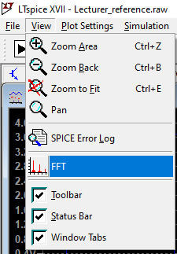

Click on the waveform that you are interested in. In this case, we are interested in Vrx.

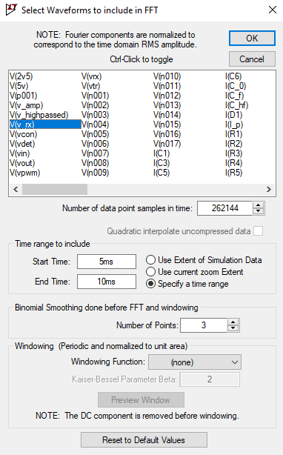

A time range can also be specified for the FFT so the transient waveforms that occur as the circuit starts up is not considered in the FFT. In this example, the time range is set to be between 5ms to 10ms to avoid the transients and only consider the steady-state waveform.

# 4. Low-pass filter

A low-pass filter is used to attenuate the higher frequency components of to make a sinusoidal waveform with minimal distortions.

An example low-pass filter circuit with labelled components is shown in Figure 4.



Figure 4: An example low-pass filter.

## 4.1 Calculation of theoretical values

Using the theory learned in the design meetings, calculate the values for the light detector circuit in Table 4. Remember to use practical E12 values for all resistors and capacitors.

### 4.1.1. Fill out Table 4 with the expected values, including units.

Table 4: Calculate theoretical values for the low-pass filter.

|  |  |
| --- | --- |
|  |  |
|  |  |
|  |  |
|  |  |
|  |  |

Here, is the passband edge frequency of the low-pass filter.

## 4.2 Design justifications

Give a brief justification for the values chosen in Table 4.

|  |
| --- |
| , , , and : |
|  |

## 4.3 Simulation

In the LTSpice model “Assignment2.asc”,finish the low-pass filter and the non-inverting amplifier circuit with the values that you have chosen. Use practical op-amps for this task

Make sure that all the values are clearly labelled, and the simulations include any auxiliary components such as sources.

### 4.3.1 Paste a screenshot of the low-pass filter circuit from the LTSpice simulation into the box below.

|  |
| --- |
|  |

### 4.3.2 Paste a screenshot of the simulated voltage waveform after the low-pass filter (V_out) into the box below when the receiver is 100mm away from the transmitter.

Use the cursor tool in LTSpice measure the amplitude and frequency of the .

|  |  |
| --- | --- |
| **Screenshot of when range is 100mm when is a 1kHz sinusoid with an offset of 3V and an amplitude of 1V.** | |
| **Screenshot of when range is 100mm when is a 2.5kHz sinusoid with an offset of 3V and an amplitude of 1V.** | |
| Simulated amplitude of (V) at = 1kHz |  |
| Simulated frequency of (V) at = 1kHz |  |
| Simulated amplitude of (V) at = 2.5kHz |  |
| Simulated frequency of (V) at = 2.5kHz |  |

|  |
| --- |
| **Screenshot of the FFT for when range is 100mm when = 1kHz.** |

### 4.3.3 Find the total harmonic distortion (THD) of and when input frequency is 1kHz.

|  |  |
| --- | --- |
| THD of (V) at = 1kHz |  |
| THD of (V) at = 1kHz |  |

### 4.3.4 (Optional) Discuss the impact the low-pass filter passband edge frequency () and the carrier frequency have on the output voltage () waveform.

Some factors to consider:

Compare the THD and FFT plots from and .

How does changing the affect the waveform of ?

How does changing the carrier frequency affect the waveform of ?

|  |
| --- |
|  |
|  |

## Obtaining THD in LTSpice

To obtain the THD of a signal in LTSpice, first run the simulation and save results only when the waveform has reached steady-state to disregard the transient waveforms.

An example of this could be to enable ‘Time to start saving data’ in the LTSpice.

Simulate -> Edit Simulation Cmd

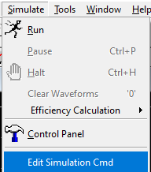

In this example, the time to start saving data is set to the last two periods of the simulation. The transients dies down at this point so only the steady-state is considered for THD.

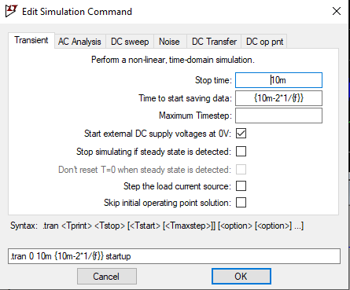

**Time to start saving data: {10m-2*1/{f}}**

A SPICE Directive needs to be set up in LTSpice to measure the frequency components starting from a specific frequency. Below is where SPICE Directives can be set.

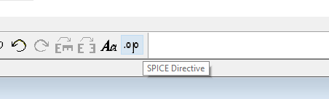

The LTSpice directive will be in the following format: .fourier frequency harmonics signal.  
An example is shown below to get the 100 harmonic components starting from the input frequency for .

**P460#yIS1**

**LTSpice directive: .fourier {f} 100 V(vout)**

*This is assuming the THD of the voltage waveform called vout is being measured. To measure THD of another voltage waveform, please change the V(vout) to the name of that waveform.*

To check the THD, View -> SPICE Error Log

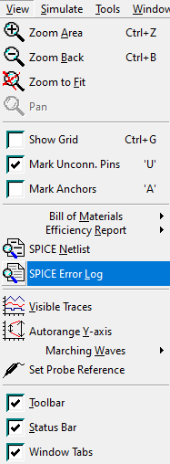

In the error log, the harmonic components of the waveform analysed is shown. The THD measured by LTSpice is listed at the end of the harmonic components.